**DAILY ONLINE ACTIVITIES SUMMARY**

|  |  |  |  |  |  |  |
| --- | --- | --- | --- | --- | --- | --- |
| **Date:** | | | **28/05/2020** | **Name:** | **JASLINE SHARON TAURO** | |
| **Sem & Sec** | | | **4th sem, A Section** | **USN:** | **4AL18CS029** | |
| **Online Test Summary** | | | | | | |
| **Subject** | 1. **DATA COMMUNICATION** 2. **COMPLEX ANALYSIS, PROBABILITY AND STATISTICAL METHODS** | | | | | |
| **Max. Marks** | 1. **30** 2. **30** | | | **Score** | 1. **29** 2. **27** | |
| **Certification Course Summary** | | | | | | |
| **Course** | | | **Trailhead Basics** | | | |
| **Certificate Provider** | | **SALES FORCE** | | **Duration:** | | **5 HRS** |
| **Coding Challenges** | | | | | | |
| **Problem Statement:**  Write a C Program to count Uppercase, Lowercase, special character and numeric values for a given String | | | | | | |
| **Status: DONE** | | | | | | |
| **Uploaded the report in GitHub** | | | | **YES** | | |
| **If yes Repository name** | | | | [**https://github.com/jaslinesharontauro/C_Prgms**](https://github.com/jaslinesharontauro/C_Prgms) | | |
| **Uploaded the report in slack** | | | | **YES** | | |

**Online Test Details: (Attach the snapshot and briefly write the report for the same)**

**Certification Course Details: (Attach the snapshot and briefly write the report for the same)**

**Coding Challenges Details: (Attach the snapshot and briefly write the report for the same)**

**1.ONLINE TEST DETAILS:**

**Today we had assessment in the subject DATA COMMUNICATION. It was based on THIRD AND FOURTH module of this subject. There were total 30 number of questions of ONE mark each, out of which I scored 29.**

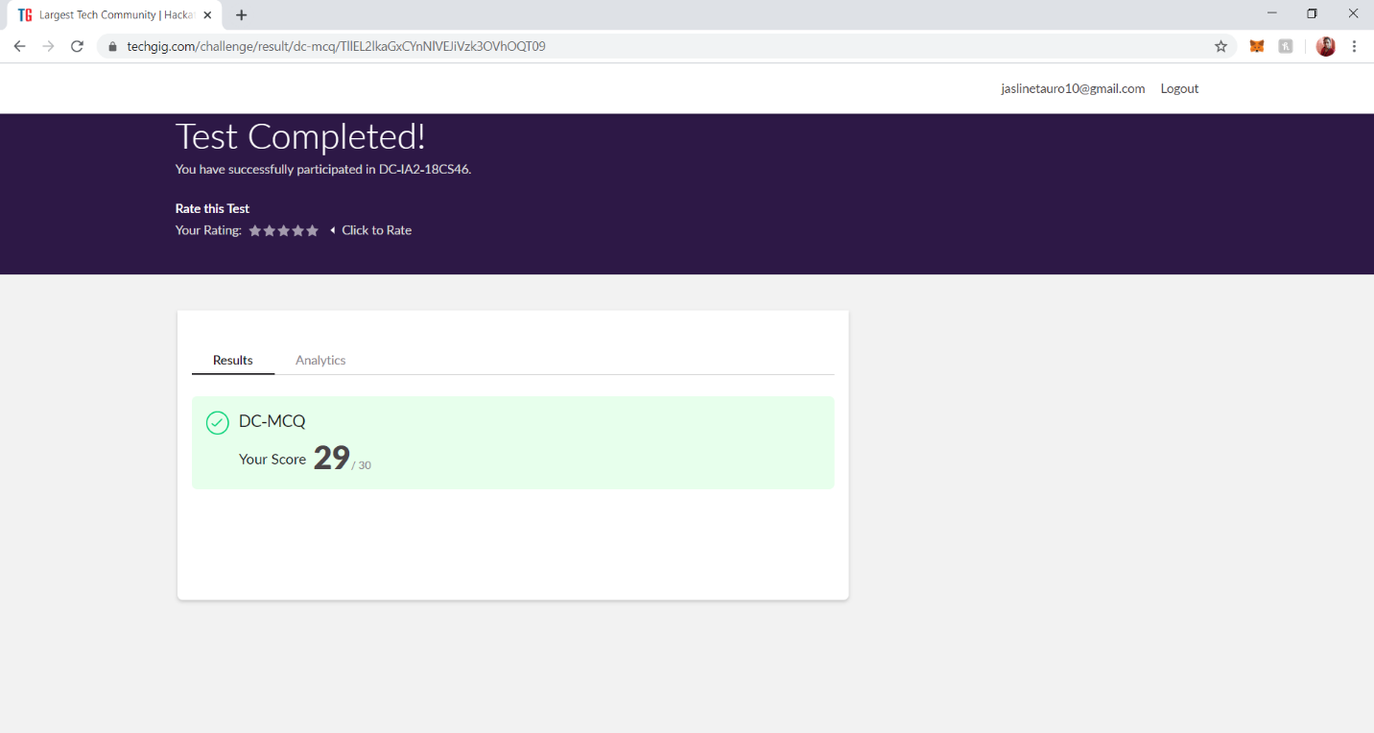

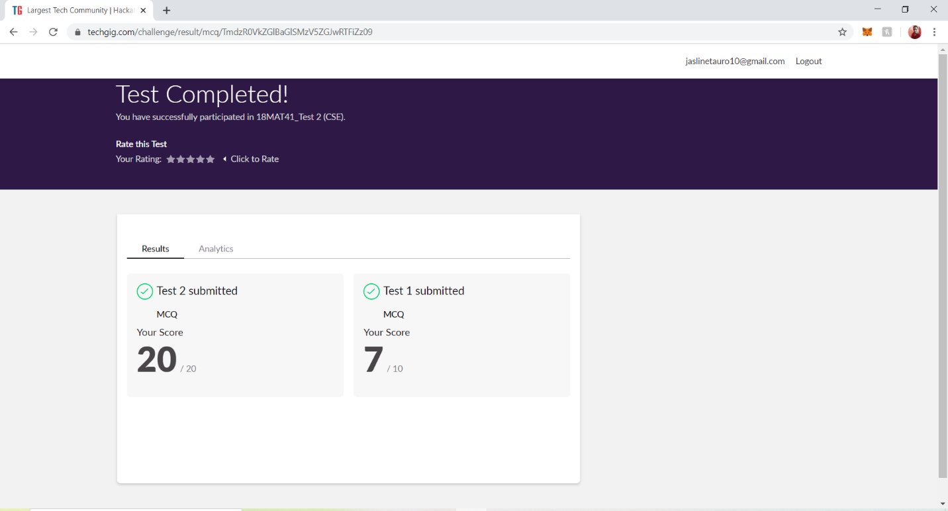**And also, we had final assessment of the subject COMPLEX ANALYSIS, PROBABILITY AND STATISTICAL METHODS. The questions were MCQ type. The test was comprised of 10 questions of ONE mark each, out of which I scored 7. And 10 questions of 2 marks each. Out of which I scored 20**

**2.CERTIFICATION COURSE DETAILS**

**Today I have done the Course named Trailhead Basics by Sales Force. Today I have learnt how to create Record Fields, Custom objects and labels.**

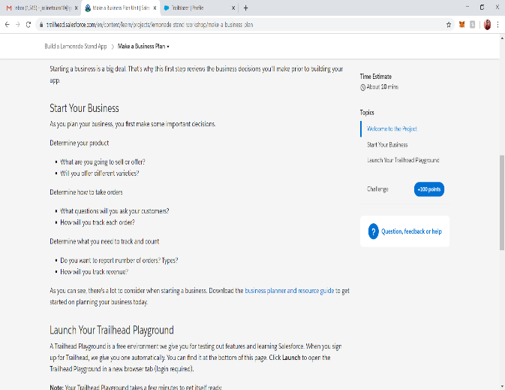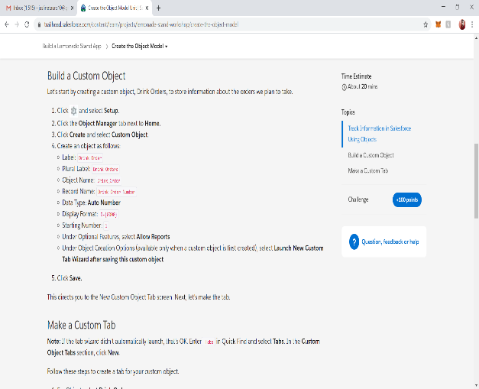

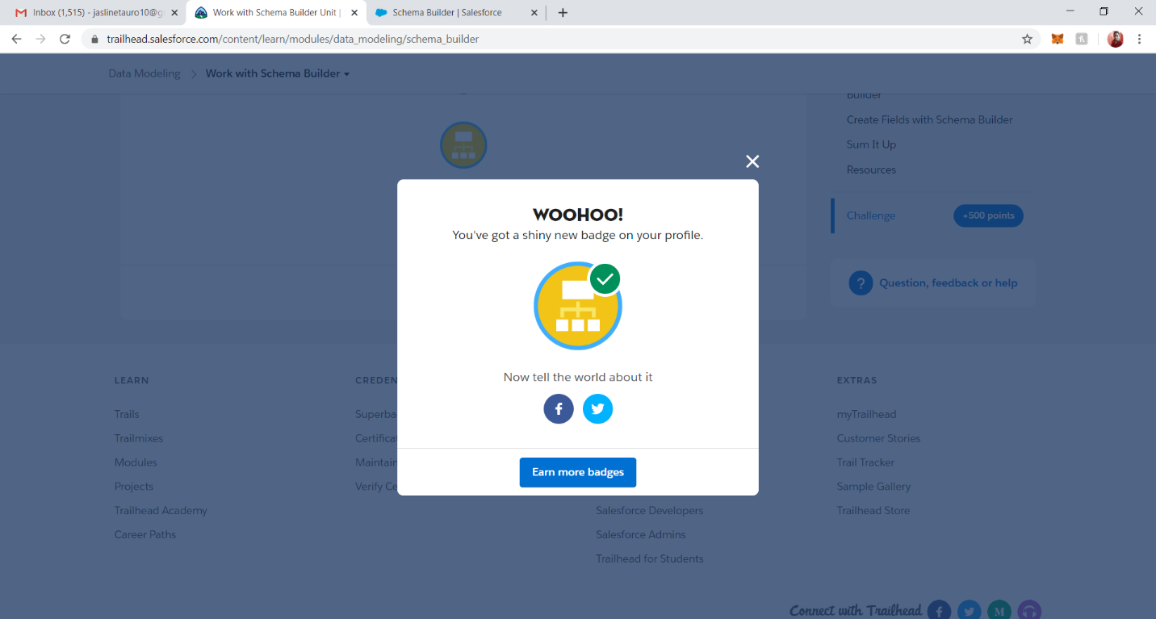

**3.CODING CHALLENGES DETAILS:**

**Problem statement 1:**

## Write a C Program to count Uppercase, Lowercase, special character and numeric values for a given String Input: Read a String (combination of character, numeric, special character) from keyboard. Ex: #HaaGs01fOr@haaks07 Output: Upper case letters: 5 Lower case letters: 8 Numbers: 4 Special Characters: 2

